Elastic seismic inversion and reservoir characterization in the Llanos Basin, Colombia
MIGUEL BOSCH, Universidad Central de Venezuela
DIEGO MORALES, YOHANEY GOMEZ, THAIS KAZMIERCZAK, TRINO SALINAS, and GABRIEL ÁLVAREZ, Pacific Rubiales Energy
ADRIANA MORENO, YOULEISSY PINO, and EDINSON MEDINA, Info Geosciences Technology and Services

Abstract
The contribution of seismic inversion to lithology and fluid characterization in oil reservoirs is geology and data dependent. Several studies of reservoir characterization based on elastic seis- mic inversion in the Llanos Basin in Colombia have proved to be successful for accurate description of the siliciclastic lithology of lower members of the Carbonera Formation. Mass density estimated from the inversion has been an important lithology discriminator because of compaction of shale, which exhibits larger densities than sand. In the analysis of properties calcu- lated from well-log data, the separation in property space of oil sands and brine sands is moderate to small. Oil sands likely are distributed toward the zones of lower VP/VS ratio, Poisson’s ra- tio, density, and bulk modulus, compared with other lithofluid types. The theoretical effect of fluid substitution in elastic rock parameters and density, although small because of the proximity of heavy-oil density to water density, is nevertheless present in these reservoirs. Successful exploitation of the seismic informa- tion associated with the discrimination of oil-bearing and brine- bearing sands has been achieved via fine calibration of the elastic inversion and derived reservoir indicators and by combining this information with relative two-way time (TWT) location of the strata to interpreted horizons. With statistical analysis and direct analysis over crossplots, indicators for oil sands have been formu- lated that are consistent with information available from wells, although slightly less accurate than lithologic (Vshale ) estimation. After lithology estimation is performed from the seismic-inver- sion results, further improvement of the lithology description is achieved by combining the seismic-derived lithology with the localized well-log lithology profiles using geostatistical methods.

Introduction
The analysis of seismic-reflection amplitudes provides a description of the elastic behavior of the propagation me- dium and particularly allows estimation of the strata elastic parameters in sedimentary basins. The accuracy of the esti- mation depends on various factors such as source energy, off- set range, energy penetration, attenuation, target depth, and others. Some of those factors are influenced by the specific geologic configuration of the area. On the other hand, the possibility of discriminating lithology or fluids or estimating porosity from the elastic description of the medium depends largely on the characteristics of the target formation, which determines the particular property relationships between res- ervoir and elastic parameters. For all those reasons, the objec- tives that can be reached via seismic-inversion analysis de- pend highly on the area and the available data set.
The Llanos Basin, in Colombia, is a wide area at the north-
east of the country that hosts prolific oil-producing fields. Oil
reservoirs are located commonly in the deepest members of the Carbonera Formation, typically at the C7 (basal sands) and C5B levels. The stratigraphic setting corresponds to deltaic and fluvial environment, reworked through extensional tectonics. Sand bodies are of good quality in general but are highly het- erogeneous and complex in morphology. Oil traps result from a combination of stratigraphic and structural features, with stratigraphic predominance. For the optimal exploitation of oil fields, a 3D description of the lithology is critical, particularly to drive horizontal drilling. Horizontal wells have been a key resource to increase production in Llanos Basin fields.
We have carried out various studies of seismic elastic in-
version with data from the Llanos Basin that include reservoir characterization based on the estimated elastic configuration of the medium. Those studies show successful results in ac- curate lithology description for the stratigraphic level of the producing members of the Carbonera Formation. In addi- tion, we have found that seismic data are sensitive to pore fluid (oil-brine), although the seismic effects associated with fluids are small compared with superposed porosity and li- thology effects. We have exploited this seismic information with fine calibration against well-log data to develop prob- ability indicators of the presence of oil sands that correlate with well information.
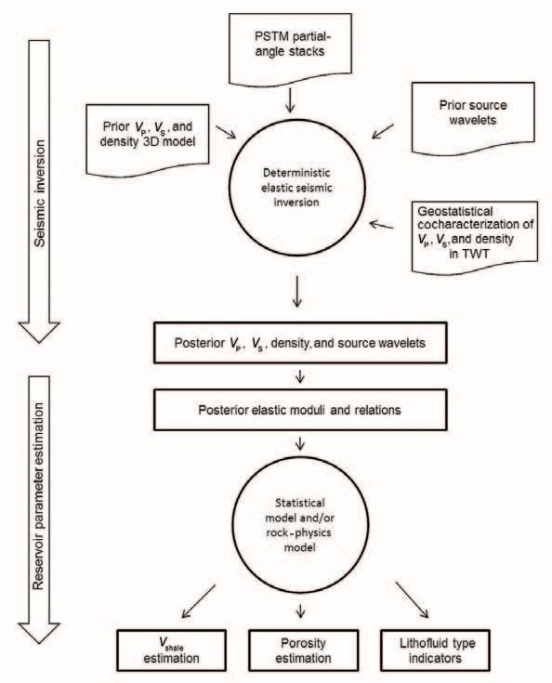
Figure 1. Basic information and process flow for the consecutive steps of seismic elastic inversion and reservoir parameter estimation.

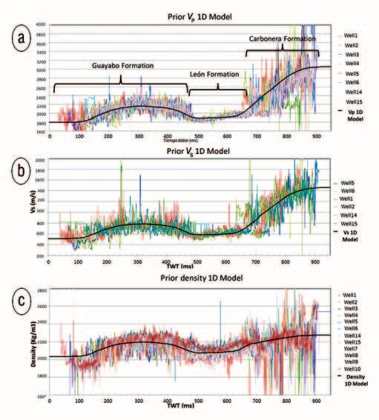

Figure 2. (a) VP, (b) VS, and (c) density profiles (colored lines) calculated from well logs in an area of the Llanos Basin against TWT after correction to a common horizon time location. The smooth trend for VP, VS, and density (black line) is used to build up the 3D prior model after extrapolation along interpreted horizons.
Oil production in the Llanos Basin is also obtained in some cases from the C3 member of the Carbonera Formation and from various Cretaceous formations in the central area of the basin. Those members and formations are not within the scope of the present work, which pertains to the lowest members of the Carbonera Formation (C5B through C7).

Methods for seismic inversion and reservoir parameter estimation
The inversion methodology we have applied is based on seismic modeling of several partial-incidence angle stacks after prestack time migration (PSTM). The modeling is performed by solution of PP reflectivity with Zoeppritz equations for the elastic isotropic medium, parameterized in layers in two-way time (TWT) domain, and convolution with seismic wavelet functions. The inversion approach is deterministic by mini- mization of a combined objective function (data deviations + priors deviations),
f (m, s) = (d – d )^{T} C ^{–1}(d – d )

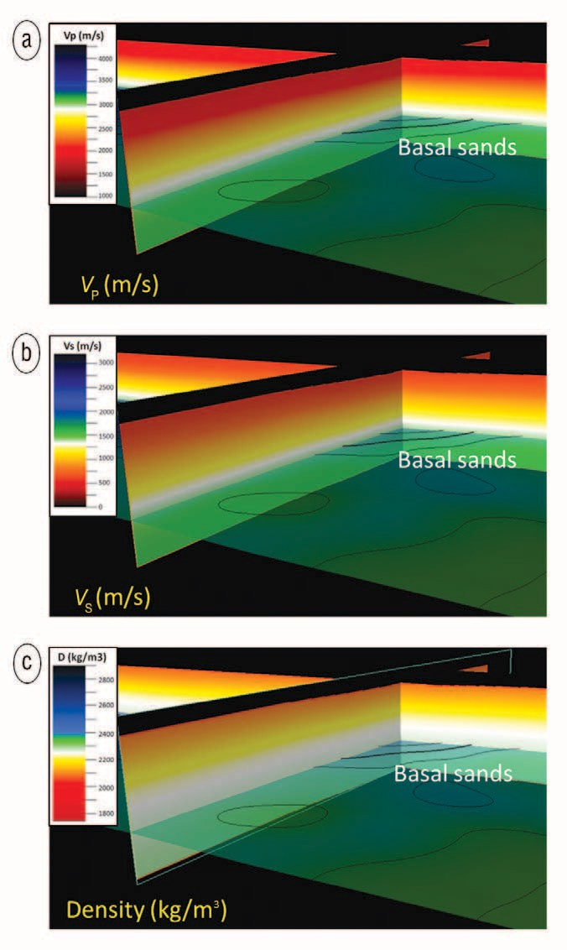
Figure 3. Sections of (a) VP, (b) VS, and (c) density prior 3D models fol- lowing the top of basal sands (C7) and the 1D area trend shown in Figure 2.

Above, d, m, and s represent modeled seismic data, elastic- medium configuration, and source parameter arrays, respec- tively; dobs is the observed seismic data array; mprior and sprior are prior configurations of the elastic properties and source wavelets; and Cd , Cm, and Cs are data, property, and source- parameter covariance, respectively.
The method includes (1) joint estimation of seismic com- pressional velocity, seismic shear velocity, mass density, and source wavelet deviations from the priors; (2) prior smooth configuration of the properties for the medium based on well- log and seismic-horizon information; (3) prior information

obs d
obs
about the vertical geostatistical characterization of the me- dium properties based on well-log data; and (4) prior source

Seismic data misfit
wavelets for each incidence angle stack. The objective func- tion is minimized via iterative linearization of the forward

+ (m – m
)^{T} C ^{–1} (m – m ) + (s –s
)^{T} C^{–1} (s – s ).
problem using a Gauss-Newton technique. Figure 1 shows a

prior m
prior
prior s
prior
flow diagram of our inversion approach.
After the isotropic elastic-medium parameters are estimat-

Medium property deviations Source-parameter
from the prior deviations from the prior
ed by seismic inversion, we proceed with the estimation of res- ervoir parameters (lithology, porosity, and reservoir oil-bearing

sand probability) based on character- ization of their relationship with the elastic properties and mass density. We combine for this purpose statisti- cal analysis and rock-physics models depending on the actual success of the indicators compared with well- log information. We have used with success (1) direct characterization and modeling by inspection of crossplots,
(2) calibration of rock-physics func- tions against property data, (3) linear regression, and (4) discriminant anal- ysis. We validate the adopted models at the level of well-log and elastic-in- version-estimated properties against lithology, porosity, and fluid content evaluated with well-log information. A review of inversion approaches for reservoir description and discussion

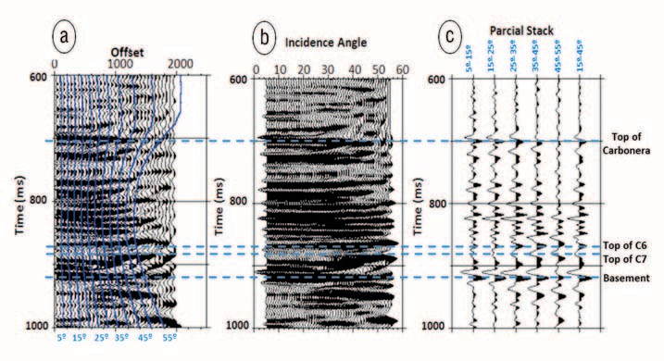
Figure 4. Example of a PSTM CDP gather (a) in offset domain with lines indicating the incidence angle dependence with offset and (b) after transformation to incidence-angle domain and (c) partial stacks at selected incidence-angle ranges: 5° to 15°, 15° to 25°, 25° to 35°, 35° to 45°, and 15° to 45°.

on some of the components used here can be found in Bosch et al. (2010).
In the Llanos Basin, we have not attempted a unified petrophysical-geophysical inversion approach because rock- physics relationships have important vertical changes across the Carbonera Formation as a result of shale compaction in the lower members. Thus, the rock-physics characterization we use for estimation of reservoir parameters is specific to the target strata, C7 or C5B, depending on the location within the Llanos Basin. First we infer the elastic parameters and mass density within a large time window for a full picture of the Carbonera Formation and the underlying basement, and then we attempt to infer lithology and fluid indicators for a smaller time window comprising the target strata.

Seismic inversion
We use a smooth prior model for V , V , and density based

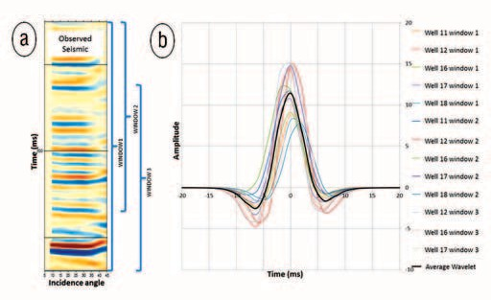
Figure 5. (a) Seismic PSTM gather at a well location and (b) various source wavelets (colored lines) estimated for several well locations and time windows at the level of the Carbonera Formation and basement reflections. The average source wavelet (black line) is used as the prior

P S wavelet for the elastic seismic-inversion process.

on a compilation of information from well-log data. An ex- ample is shown in Figure 2, which displays well logs for mass density, VP, and VS in a typical Llanos area and a common multispline model that follows the long-period trend of the properties. For this plot, well-log data are correlated in time to a common well location according to appropriate seismic horizons. The 3D prior property model is extrapolated from the 1D common trend following the reference-interpreted seismic horizons. Figure 3 shows prior property models.
Carbonera target levels are relatively shallow, between 800 ms and 1000 ms TWT for the areas studied, and penetration of high frequencies is good when explosive sources are used. The common processing sequence we recommend is basic, in- cluding predictive or spiking deconvolution, surface-consistent amplitude recovery, and prestack time migration. Dominant frequency at the target level is within the range of 80 to 120 Hz. By the criterion of a quarter dominant period, we achieve in most cases a property-model resolution of 2 ms, the same as the seismic sampling interval. As a complement to a simple processing sequence, we are encouraged to carry on more
elaborated processing strategies (such as advanced migration algorithms, moderate frequency enhancement, interpolation, and so forth) that can contribute to seismic-imaging improve- ment while respecting reflectivity amplitudes — always having a close interaction with the interpreters for quality control.
Figure 4 shows a typical CDP offset gather after PSTM and its incidence-angle mapping. In this case, we have par- tially stacked traces within 10° incidence-angle bins, starting at 5° to 55°. The angle coverage is dependent on the geometry of acquisition. For standard geometries, the smallest and larg- est of the angle bins commonly are subjected to spatial non- homogeneous fold of coverage generating acquisition-ampli- tude footprint effects. This commonly has been the situation for partial stacks with the smallest angle (5–15°) and largest angle (45–55°). After testing, we have found better results excluding the extreme short and extreme large angle-range bins and retaining as input for the inversion the better spa- tially sampled small (15–25°), medium (25–35°), and large (35–45°) incidence-angle partial stacks.

We estimate the source wavelet in three steps:
- standard seismic modeling from impedance well logs for well-to-seismic matching and approximate assessment of the frequency and phase source wavelet
- stochastic modeling of the source wavelet against PSTM gathers for further adjustment of wavelet shape and angle dependency
- final adjustments of source-wavelet devia- tions in the seismic-inversion process esti- mated jointly with VP , VS , and density on a CDP-per-CDP base, to assess spatial varia- tion of the source wavelet
Figure 5 shows a CDP PSTM gather and various wavelets estimated via stochastic analy- sis for various well locations and time windows, as mentioned in item 2 above. In this particular case, we did not need to consider a variation of the wavelet with the incidence-angle ranges. Figure 5 also shows an average wavelet which is the prior source wavelet for the inversion, step 3 in the sequence.
The prior property model is adjusted in iter- ative steps through inversion to estimate strata-
property (VP, VS , and density) deviations from the prior that explain the seismic reflections at various partial-angle stacks. Figure 6 shows a detail of the observed, calculated, and differ- ence (residual) incidence angles of the seismic partial stacks. Figure 7 shows the corresponding estimate of the strata mass density, VP, and VS . As previously explained, the inversion jointly estimates deviations of source wavelets for each partial-angle stack and CDP. Figure 8 shows an example of the prior, final, and dif-
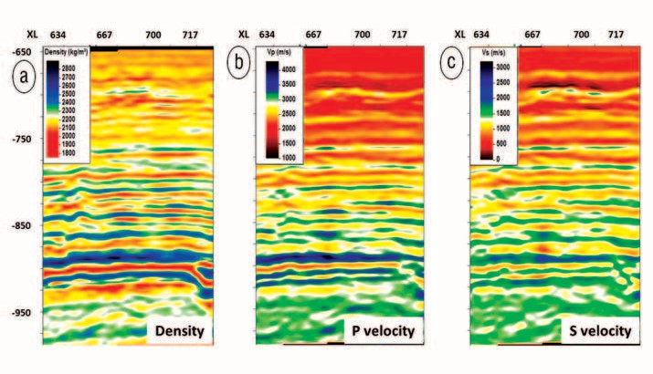
ference source wavelets along an in- line section through the volume.

Lithology characterization
One major objective of the inver- sion is lithology inference; we have already mentioned the importance of 3D mapping of sand bodies for hor- izontal-well locations in the Llanos Basin. The basin’s siliciclastic Carbo- nera Formation lithology is described by shale volume fraction (Vshale ). At the lower (older) members, we have found a good relationship between mass density and Vshale. Because of shale compaction, shales have larger mass density than sands. Figure 9

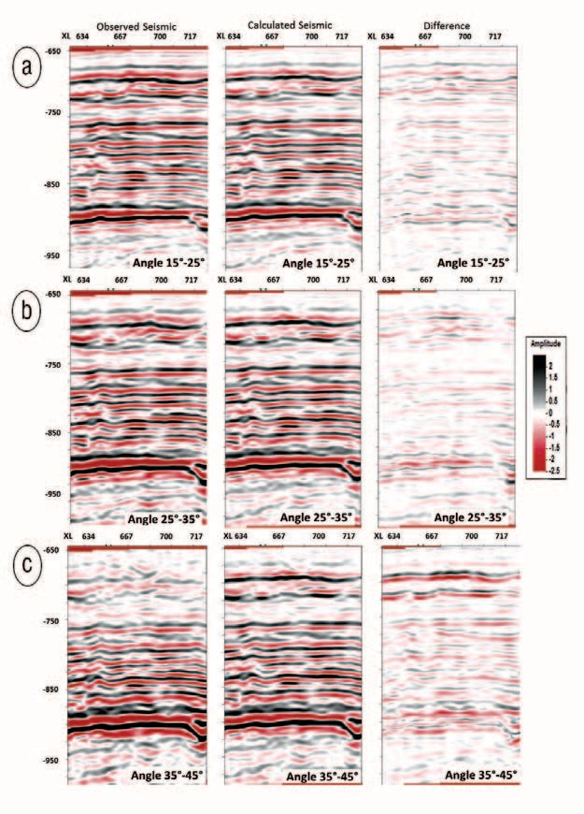
Figure 6. Observed, calculated, and residual incidence-angle partial stacks for incidence-angle ranges of (a) 15° to 25°, (b) 25° to 35°, and (c) 35° to 45°.

shows an illustration of this relation- ship based on well logs for various
Figure 7. (a) Mass density, (b) VP, and (c) VS estimated by elastic inversion for the same seismic data section shown in Figure 6.

wells at C6 and C7 levels. The correlation factor between den- sity and Vshale is 0.7 in these well-log-derived data.
We have explored other relationships and multivariate
predictions. However, the best estimation of a seismic Vshale has been obtained with direct linear regression from the mass density inferred from seismic inversion after a logarithmic transformation of the shale volume factor.
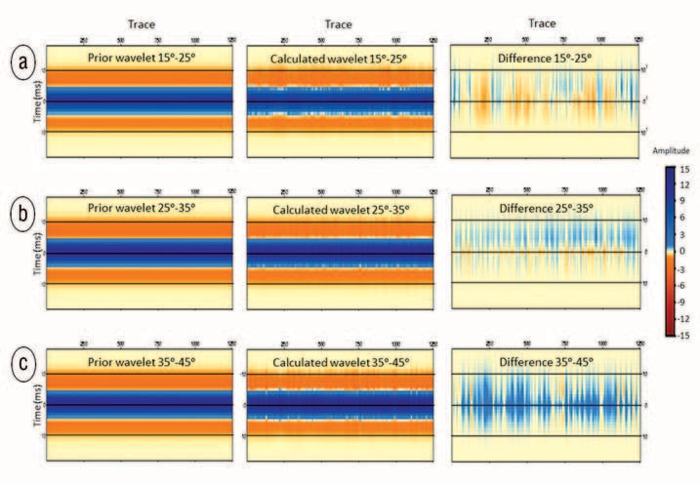
Figure 10a shows a section of the Vshale estimator and the corre- sponding Vshale profile derived from well-log data at an example well. We found good correlations between the Vshale estimator derived from the in- version study and the well-log data, with a correlation factor of the order of 0.8 on large sets of control wells (more than 20) distributed across large seismic-survey areas (more than 250 km2). Our statistics clearly show that lithology prediction based on prestack seismic-reflection data for the Llanos basal Carbonera sand formation is successful.
Figure 10b shows the Vshale esti- mation and two horizontal wells suc- cessfully drilled through the produc- ing basal sand strata. The resistivity log is plotted to the side of the well
basal sands — as inferred from the low shale fraction esti- mated from seismic inversion.

Total-porosity characterization
We have applied various statistical procedures for the prediction of total porosity. One of the approaches is lin- ear multivariate regression from various elastic moduli and

path, showing a good correlation between the oil-related increase of resistivity and the quality of the top
Figure 8. Prior source wavelet, calculated source wavelet, and their difference for each incidence- angle partial stack along an inline through the data volume: (a) 15° to 25°, (b) 25° to 35°, and (c) 35° to 45°.

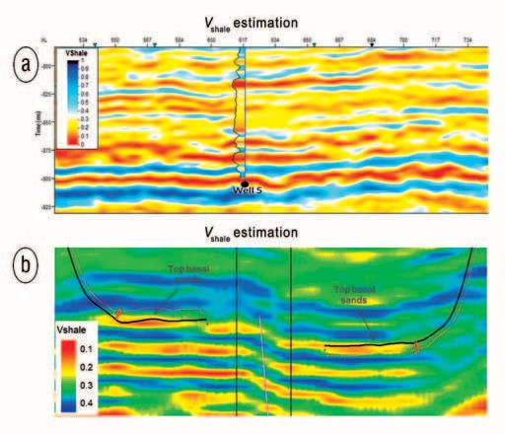

Figure 9. Mass density and shale volume fraction data calculated from well logs at the levels of the C6 and C7 Carbonera Formation members. The correlation factor in these data is 0.7.
Figure 10. (a) Vshale derived from seismic inversion and a Vshale profile calcu- lated from well-log data for a vertical well. Well-to-seismic Vshale estimation is of 0.8 correlation factor in average over the 17 control wells in this
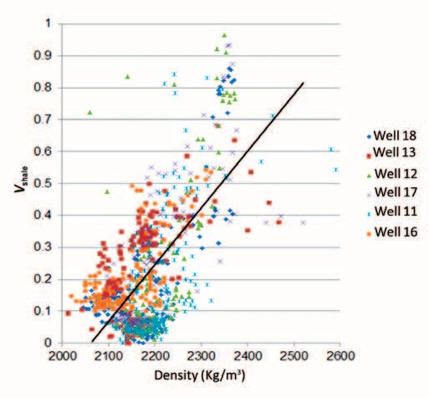
area. (b) Vshale derived from seismic inversion and horizontal well paths drilled with successful arrival in the oil-bearing sand stratum. The black line shows the trajectory to the wells, and the red line to the side of the trajectory is a resistivity log. Notice that oil-associated increase in resistivity has good correlation with the estimated quality of the top basal sands.

July 2014 The Leading Edge 739

mass density. Figure 11a, based on a different seismic data set than Figure 10, shows a section of total porosity derived from inversion with a 0.8 correlation factor with well-log information, obtained via multivariate linear regression. An- other approach is calibration with well-log data of simple rock-physics relations, such as the relation of density to po- rosity and the relation of Wyllie slowness to porosity and their combination.

Oil-bearing sand characterization
Oil in the Llanos Basin is of heavy or medium API grav- ity; its mass density and acoustic properties have small de- viations from the corresponding brine properties. Because of this deviation in elastic properties, there is a direct seismic- reflectivity effect of the fluids in the pores for the basal Car- bonera Formation, although small compared with lithology and porosity effects. However, depending on the area, seismic data quality, and appropriate seismic data to well-log calibra- tion, the fluid information imprinted in seismic reflections can be exploited. In general, oil-bearing basal sands at C7 are more likely to be distributed in the zone of low mass density, low VP/VS ratio, low Poisson’s ratio, and low bulk modulus than the corresponding brine-bearing sands.
Figure 12 shows an example of crossplots of oil-bearing sands, brine-bearing sands, and shaley sands corresponding to Carbonera C6 and C7 members with property data calcu- lated from well logs (Figure 12a), a fluid-substitution model (Figure 12b), and seismic inversion (Figure 12c). Although significant overlap of lithotype support in the crossplots is

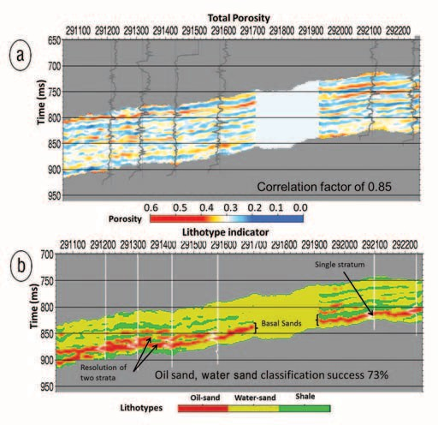
Figure 11. (a) Total porosity estimated from seismic inversion and porosity profiles from well logs. Well-to-seismic porosity estimation is of 0.8 correlation factor in this area. (b) Most likely lithotypes obtained from probability densities defined in a discriminant space resulting from the linear combination of elastic parameters for oil sand, brine sand, and shale. The discrimination also includes TWT relative to the top of target stratum C7. This image is not from the same data set as previous figures.

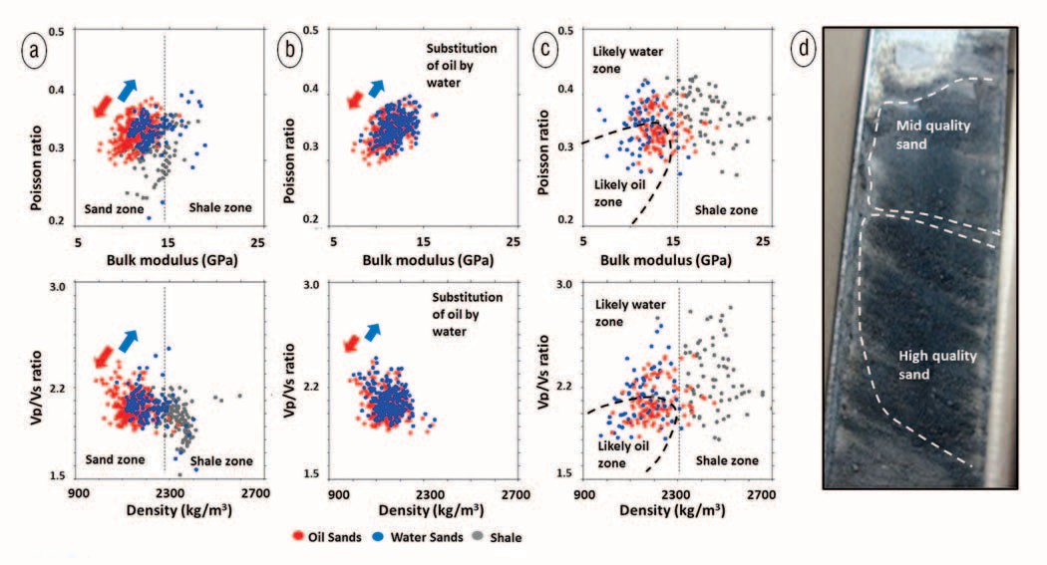
Figure 12. Crossplots of lithotype samples in several well locations corresponding to oil-bearing sand, brine-bearing sand, and shaley sand, according to (a) well-log-derived properties, (b) a fluid-substitution model, and (c) seismic-inversion-derived properties. In the fluid-substitution case, water-sand samples (blue) are modeled from the oil-sand samples (red) of part (a). (d) Photographic image of a core sample from C7 oil- bearing sand showing porosity heterogeneity.

shown, there are higher probabilities for oil in pores in the indicated lower areas of the crossplots.
The fluid-substitution exercise (Figure 12b) shows the direction of displacement of rock properties caused by fluid change, in agreement with that observed in the crossplots of well- log data. Note that fluid substitution based on the Gassmann model (Ma- vko et al., 2003) does not fully account for the size of property displacements shown in the well-log-derived data. We think the fluid effect might be re- inforced by associated frame and pore effects, such as larger permeability of oil-bearing sands or better preserva- tion of pore space after migration in oil sands compared with brine sands.
Figure 12d illustrates heterogene- ity in porosity of basal sands. Heavy- oil saturation is associated with prefer- ence to high-quality sands, which are characterized by larger porosity and permeability.

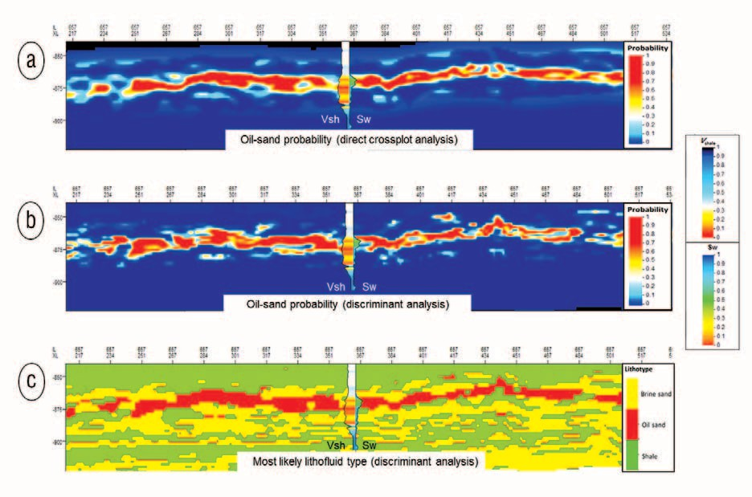
Figure 13. Well-log-derived Vshale and water-saturation profiles superposed to oil-sand probabilities calculated from the results of elastic inversion and based on (a) direct characterization in the space of properties and (b) discriminant analysis. (c) Most likely lithofluid types inferred via discriminant analysis based on the results of inversion. In all cases, TWT information relative to the top of the target stratum C7 is included.

We have exploited the small to moderate fluid effect in prop- erties and reflectivity by the construction of lithotype probabil- ity indicators, using two methods: (1) on direct selection at the elastic parameter and mass density space and (2) in discriminant space after discriminant analysis. For those indicators, we com- bine the information on property distribution of the oil-sand lithotype with probabilities associated with the location of the C7 target sands within the appropriate time window and the related interpreted time horizon for stratum-formation specificity of the indicator. In both cases (direct or discriminant space), we have obtained coherent results of the oil-sand indicator against well-log data with a correlation factor to well-log information that ranges between 0.7 and 0.6, depending on area and data quality.
Figure 11b, from a different seismic data set than the one shown in Figure 10, shows lithotype indicators derived from the discriminant-analysis approach. The indicator is super- posed to saturation profiles derived from well-log data show- ing assertive correlation for the oil-bearing sand strata and their levels — two levels at the right-hand side of the figure
— with a correlation of 0.7 to oil saturation.
Figure 13a (from the same data set shown in Figure 10) shows probabilities for oil sands based on probability densities directly selected from analysis of property crossplots, which has a correlation of 0.6 with oil saturation at 17 control wells in the area. Figure 13b shows probabilities for oil-bearing sands obtained with a discriminant-analysis approach with similar correlation to well-log information. Figure 13c shows the most likely lithotype derived from discriminant analysis.

Maps and geostatistics
Based on vertical integration of the Vshale estimator and probabilities for oil sands, various types of maps are produced.

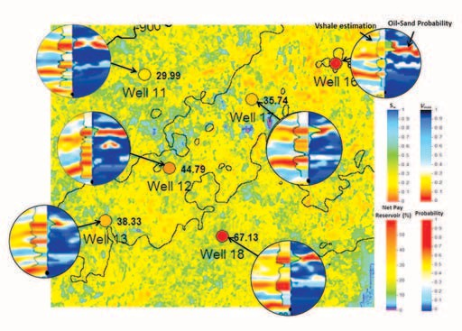
Figure 14. Map of net-pay-to-gross ratio for C7 sand with super- position of values calculated from well data at six locations. The overall correlation factor over 17 control wells in the area is of 0.7. Circular plots show for each well location the seismic-derived Vshale estimator, the probability for oil sand, Sw, and Vshale according to well-log data.

Figure 14 shows an area with net-pay-to-gross calculations and comparison to well-log data with overall correlation of 0.7.
Spatial horizontal sampling available through the seis- mic-derived lithology and lithotype estimators can be used for geostatistical characterization of the horizontal variabil-
ity of Vshale and saturation. Figure 15 shows an image of C7, with the empirical and modeled standardized variogram. The variogram shows ranges for sand bodies of approximately 2 km with an exponential variogram that displays the known

morphological heterogeneity of sand distribution. Combination of the seis- mic Vshale estimator with well-log data via geostatistical methods, such as cokriging, improves the precision of 3D estimation of sand bodies.
Figure 16 shows a slice through the Carbonera C7 Vshale seismic estimator and the resulting update obtained by combi- nation of the Vshale seismic estimator with the well-log Vshale at well locations using a cokriging strategy. By construction, the updated result shown in Figure 16b hon- ors the well-log lithology at well locations.

Conclusions
Combination of seismic elastic inver- sion and statistical rock-physics reservoir- property estimation is useful in the Llanos Basin for providing an accurate descrip- tion of lithology at the Carbonera For- mation, particularly for the estimation of shale volume fraction in three dimensions, which is important for development of the producing fields via horizontal drill- ing. Further combination in three dimen-

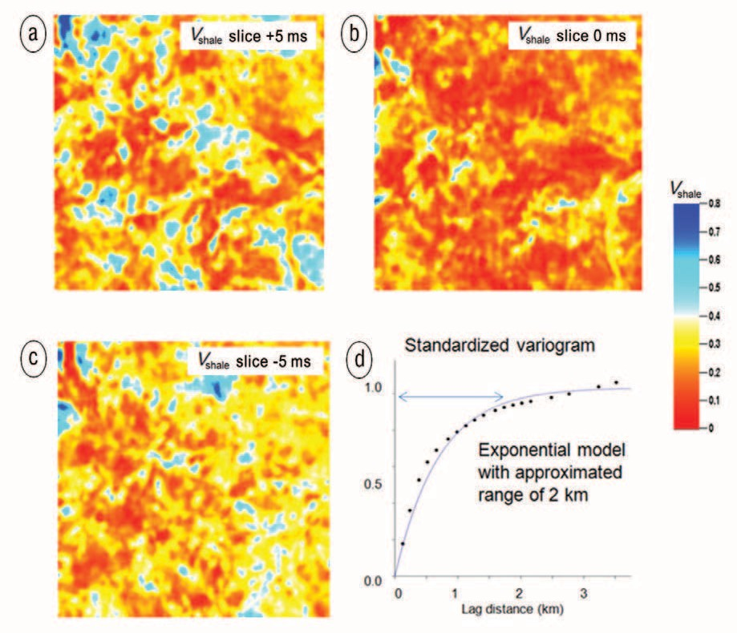
Figure 15. (a through c) Parallel horizon slices through the seismic estimator of Vshale at the

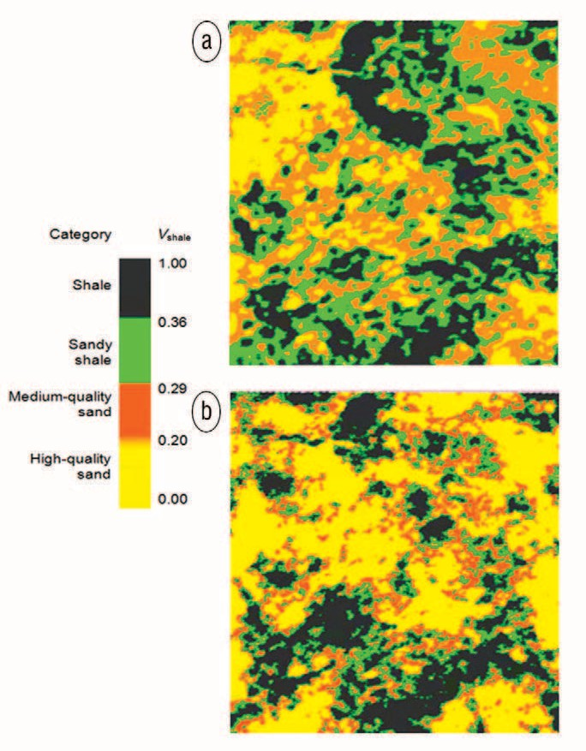
sions with localized well-log information via geostatistical tools improves the accu- racy of the sand model.
center of the C7 sand strata. (d) The corresponding empirical (dots) and modeled (continuous
line) spatial semivariogram.

In our studies at the Llanos Basin, mass density is an impor- tant parameter for lithology description because of its correla- tion with the shale volume fraction in Carbonera basal sands (C7). This behavior is also shown at the lowest strata of C5. In addition, total porosity can be estimated successfully from elas- tic parameters and mass density inferred from elastic inversion. The direct effect of oil-brine substitution in sandstone pores, although small because of the density of heavy oil, can be ex- ploited by means of fine calibration and horizon interpretation to develop oil-bearing sand-probability fields and most likely lithotype fields that are coherent in reproducing well-log infor- mation. Oil-bearing sands, although with significant support
overlap, are more likely to be of lower mass density, lower VP /VS ratio, lower bulk modulus, and lower Poisson’s ratio than brine- bearing sands, as expected by rock-physics modeling.
References
Bosch, M., T. Mukerji, and E. F. Gonzalez, 2010, Seismic inversion for reservoir properties combining statistical rock physics and geo- statistics: A review: Geophysics, 75, no. 5, 75A165–75A176, http:// dx.doi.org/10.1190/1.3478209.
Mavko, G., T. Mukerji, and J. Dvorkin, 2003, The rock physics hand- book, 2nd ed.: Cambridge University Press.

Acknowledgments: We thank Pacific Rubiales Energy and Info Geo- sciences Technology and Services for their authorization to publish the data shown in this article.
Corresponding author: miguel.bosch@ucv.ve

Figure 16. Horizon slice through (a) the seismic-derived Vshale estimator and (b) the seismic-derived Vshale estimator after combination with the localized well-log information on Vshale by cokriging.

